Silverdale Primary
School

PEAKS
CHALLENGES

Term 3 and 4
2017

Year 0 /1 PEAKS Challenges

- This is a voluntary home – school learning programme,
it does not replace reading and spelling homework.

- You must complete 3 challenges per term with a total of 12 challenges completed for the school year.

- You may complete more than 3 challenges if you wish.

- Each of the 3 challenges per term MUST come from a different section.

- In each section is a “design your own challenge.” You may write your own challenge with the help of your teacher or parents. Your own challenge must be approved by your teacher.

- All challenges MUST be recorded in some way. You may choose to complete the challenge log sheet or keep a record of your own. Completed challenges must be signed off by your teacher.

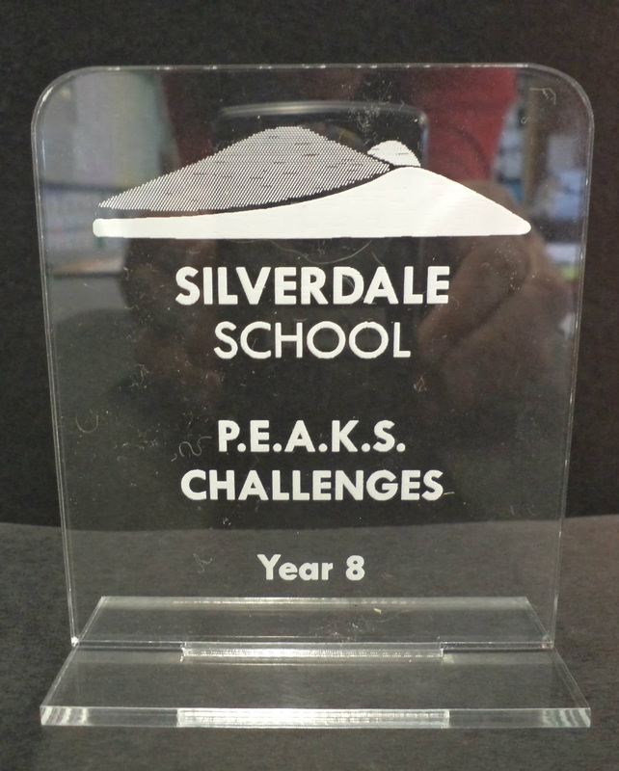
- Quality and not quantity is the main emphasis of this programme. Take time to complete each chosen challenge to the best of your ability.

- The most important thing to remember is to have…

FUN!!

Year 0/1 PEAKS Challenges

Participation: | S | P | T
- Do 1 chore per day for at least 1 week
- Take responsibility for your pet for at least 1 week (feeding/cleaning etc)
- Explain to your family how to fill a bucket. Draw 5 different ways you help to fill buckets of people in your family.
- Communicate with someone in your family to find out something interesting about them - using the mail or email
- Participate in a club/ team activity outside of school for a term. E.g. Pippins, cubs, sports teams, etc
- Share a story or poem with someone in your family
- Design your own challenge

Environment: | S | P | T
- Pick up rubbish within an area of your community e.g. park or beach
- Grow and care for a plant/ insect, record the different stages of the plant’s growth/ insect’s life cycle
- Re – use recyclable materials to create a musical instrument/ toy/piece of artwork
- Map a sustainable journey e.g. catching the bus, scooter, car pool somewhere
- Complete 4 walks in the outdoors with your family
- Record the weather over a period of at least a week and draw conclusions from it eg. the coldest day was 3 degrees
- Maintain a compost bin at home
- Design your own challenge

Action: | S | P | T
- Keep my room tidy for at least a week
- Pack and unpack my own bag everyday for the week we have school swimming with all the things I need.
- Play a game using a small ball with my friends and or family. E.g. target throw, T. Ball, hit/ run
- Be active everyday for a minimum of 30 minutes a day
- Donate unwanted goods or toys to charity
- Follow a recipe to prepare a treat or a meal
- Keep a diary or journal over a term
- Design your own challenge

Knowledge: | S | P | T
- Write 5 facts about a sea creature
- Collect and sort items (from nature) into groups and display my findings
- Design a poster detailing how we care for our bodies e.g. brushing teeth etc
- Visit the local library to choose at least 3 books to enjoy with my family
- Retell a familiar story, adding sound effects and actions relevant to the story
- Record my surname, address, phone number and birthday
- Count to 20 or 50 (for a real challenge) both forwards and backwards
- Complete and record a science experiment
- Design your own challenge

Skills: | S | P | T
- Make up a dance to music and perform it to my family/class
- Design a family crest
- Create and practice an emergency action plan to keep your family safe in the event of a natural disaster
- Make up a dance to music and perform it to my family/class
- Make a timetable of a week in your life
- Draw and name birds from your garden or local environment
- Play a number board/card game and show fair play
- Put my shoes on independently and do them up
- Design your own challenge

PEAKS CHALLENGES LOG
YEAR 1 2017

Name:

Room:

Activity Description:

Participation Environment Action Knowledge Skills

(Please tick the challenge category)

Date | Log entry.  Give a brief description of your ideas, planning and progress. | Discussed & signed by parent or teacher.  (Record any comments here)

